LOCAL RESOURCES FOR UTILITY ASSISTANCE

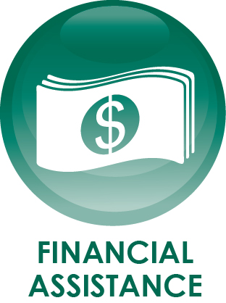

In City of Cochran area, there are very few agencies that routinely provide services to City residents in our community experiencing hardships. With the help of some programs, citizens can connect with the assistance that is needed. Due to limited funding & eligibility requirements, some program acceptance is not guaranteed. Below is a list of some local community agencies that may have resources available.

FIRST BAPTIST CHURCH (THE HANGAR) | (478) 934-6356
WILLING HANDS MINISTRY CENTER | (478) 934-1044
MIDDLE GEORGIA COMMUNITY ACTION AGENCY | (478) 934-4012
THE SALVATION ARMY CENTRAL GA | (478) 746-8572

